**STUDY NOTES.**

**BIOLOGY FORM ONE.**

**INTRODUCTION TO BIOLOGY**

**What is biology?**

Biology is a study of living things or organism.

Or

Biology is the branch of science which deals with the study of life and living things.

Living things include bacteria, fungi, animals, plants etc.

Biology is derived/comes from two Greek words;

                                       Bios – means “Life”

                                         Logos – means “study”

The people who study biology are called **Biologist**.

Very small organism are called **microorganism**.

The simplest living things are made up of one cell these are called unicellular organism e.g. bacteria, protozoan and amoeba (also are called microscope organism).

Large organisms are made up of many cells these are called multicellular organism e.g. fish, trees, man

**WHAT IS LIFE**

Life is the state of living which plants, animals, and other living organisms have before they die.

**BRANCHES OF BIOLOGY**

There are two main branches of biology

(1) **Botan**y – Study of **plants**

(2) **Zoology** – Study of **animals** only

However there are many minor branches of biology. That deal with different aspects of living things

Example;

|  |  |
| --- | --- |
| **BRANCHES** | **AREA OF STUDY** |
| 1.Anatomy | Physical structure of organisms |
| 2.Cytology | Deals with cell |
| 3.Ecology | Relation between organisms and their Environment |
| 4.Mycology | Deals with fungi |
| 5.Taxonomy | How organisms are named and groups |
| 6.Physiology | How organisms body parts function |
| 7.Parasitology | Deals with parasites |
| 8.Immunology | The body defense against infections and disease |

**IMPORTANCE OF STUDYING BIOLOGY**

1. It helps a man to understand himself/herself better
2. Knowledge of biology enables human being to conserve the environment.
3. It helps man to evaluate environment uses such as pollution, global warming and environmental degradations.
4. Biology help to understand cause, symptoms, method of transmission, prevention, and treatment of diseases this improve the standard of living.
5. It provides answer to fundamental questions .e.g. who am i?
6. It helps us to enter in careers such as medicine, agriculture, reproductive, health and genetic Engineering.
7. Biology helps us appreciate nature.

**THE RELATIONSHIP BETWEEN BIOLOGY AND OTHER SUBJECT FIELD**

Biology related to many other field of study such as agriculture, medicine, pharmacy such as veterinary, medicine and nutrition.

1. **AGRICULTURE**

Biology research finding on crops and livestock have led to improve agriculture production.

1. **MEDICINE AND PHARMACY**

Medicine is the study of prevention and treatment and cure of disease.

1. **NUTRITION**

Biology is used by dieticians to determine the kind of diets suitable for people with different health problems.

1. **FORESTRY**

Biologists have developed varieties of trees that grow well in dry areas, also that mature fast so as to prevent desertification.

**CHARACTERISTICS OF LIVING THINGS**

Living things have characteristics which make them different from non- living thing. These are;

1. **NUTRITION/ FEEDING**

All living things take in food or make their own food. Food enables living things to grow, develop and carry out on life process.

1. **RESPIRATION**

Respiration is a process by which food substances are broken down to produce useful energy in a cell.

3.**EXCRETION**

Is the process by which excess waste or harmful material resulting from the chemical reaction occur in body cell are removed out of body.

1. **SENSITIVITY/ IRRITABILITY**

It is the ability of an organism to detect and respond to a change in its environment

1. **GROWTH**

Growth is an increase in size and mass of an organism that becomes more complicated and more efficient.

    6.  **MOVEMENT/ LOCOMOTION**

Is an action of changing posture or position of an organism. Locomotion is the Movement which involve the whole body. E.g. Animals but plants just show movement in term of growth of their body parts. E.g. roots, shoots and leaves.

1. **REPRODUCTION**

Is the process whereby living things give rise to new individuals of their own kinds. This ensures that there is continued existence of the species and life forms.

Non- Living things are referred to as inanimate

Living things are referred to as animate

QUESTIONS

1. Outline the importance of biology
2. Mention characteristics of living things
3. Give five examples of living things and non-living things

**SCIENTIFIC PROCESS IN BIOLOGY**

Biology is a practical science that involves carrying out experiment, observation, measuring and experimentation are skills that we need when studying Biology, and we use our sense organs to make observation.

These organs are;

1. The eyes for seeing
2. The nose for smelling
3. The ears for hearing
4. The tongue for tasting
5. The skin for feeling

Scientific measurements are taken using specific instrument and units.

**Some basic biological measures are**

|  |  |  |
| --- | --- | --- |
| MEASURE | INSTRUMENT | SI UNIT |
| Mass | Beam balance/Digital balance | Kilogram (kg) |
| Time | Watch | Second (s) |
| Length | Ruler | Meter (m) |
| Temperature | Thermometer | Kelvin (K) - Degrees Celsius                   -Degree Fahrenheit |

In biological investigation like in any other scientific research, methods are listed. The scientific method is a set of steps that scientist use to study things.

Those methods are

1. Problem identification

2. Formulation of hypothesis

3. Experimentation

4. Observation and data collection

5. Interpretation of data.

6. Conclusion

**Problem identification**

Is the process of identifying the problem

Example, it is observed that buffaloes in Serengeti Park are dying at great rate what would be the cause of death?

**Formulation of hypothesis**

It is an intelligent guess that tries to explain as an observation

Therefore experiment should be designed, proved or disapproved. If hypothesis is correct we say it is accepted, if disapproved we say rejected.

**Experimentation**

An experiment is a test that is carried out under controlled conditions to determine whether a hypothesis is correct or not. In any experiment there is control experiment and experiment test.

**Observation and data collection**

The scientists observe what happens from the time the experiment was set up to the time it ends. It is important to note all the changes made from the beginning to the end of the experiment and recording

**Interpretation of data**

At the end of experiment the scientist analyses the observations and Data recorded. The scientist may look for pattern or in the data               .

**Conclusion**

A conclusion is a statement that summarizes what a scientist has learnt from an experiment. When scientist read conclusion, they taste whether the data or information collected support the hypothesis (accepted) or not support the hypothesis (reject), if so another hypothesis must be formulated and repeat the whole experiment.

**BIOLOGY LABORATORY**

**A laboratory** is a special room designed for carrying out scientific experiment.

**A biology laboratory** is a special building designed for carrying out biological experiments.

A laboratory should have adequate space for carrying out experiment,

Proper lighting, and good ventilation,

Source of water, and means of heating,

Adequate space for storing apparatus, chemicals and specimens.

**LABORATORY RULES**

In biology laboratory we use hazardous chemical, fragile equipment or dangerous specimens. For this reason, it’s important to follow a certain rules and regulation for our safety and safety for others.

**These rules are;**

1. Do not go into the laboratory in the absence of a teacher or laboratory technician.
2. Do not handle or use apparatus, chemicals or specimens in the absence of a teacher.
3. Do not taste/ eat substances during experiment
4. Know the location of all exits
5. Do not leave experiment unattended
6. Turn off gas and water taps when not in use
7. Do not burn substances towards other people in the laboratory
8. Do not take laboratory equipment’s, chemicals or specimens out of the laboratory
9. Do not play or run in the laboratory
10. Read the labels or containers before using the contents. Do not interchange label.
11. Dispose all waste materials after all experiment.
12. After each experiment clean all the equipment’s you have used
13. Avoid touching yourself while performing experiment, clean your hands with soap and water after Experiment.
14. Do not touch electrical equipment with wet hands.
15. If you don’t understand something ask your teacher.
16. Know the location and operation procedure of all safety equipment e.g. First aid and fire extinguishers.
17. Dress properly for laboratory activities, tie back long hairs. Do not wear dangling Jewelers, Sandals. Shoe must cover a leg completely.
18. Report all accidents immediately to your teacher or technician
19. Never use dirty, chipped or cracked equipment.
20. Handle live spacemen carefully. if an animal bites or insect stings you, report the accident to your teacher

## What is in the laboratory?

-In the Biology laboratory we can find ***specimen*** and ***models***.

-Equipments and Apparatus for carrying out biological experiments.

-Sinks and water supply.

-Gas supply and burners (Bunsen burners and spirit burners)

-Fridge for storing specimen

-Oven for drying specimens or for experiments to culture bacteria.

-It has large windows for enough supply of air and light.

**WARNING SIGNS/ SAFETY SYMBOLS**

These are signs that are found on apparatus and chemical containers used for caution or providing information.

Some may be found in or on the boxes used to hold either chemicals or apparatus.

These signs must be obeyed in order to ensure safety in the laboratory before one uses a chemical, one should know whether that chemical is Toxic, Corrosive, Flammable, Oxidant, Explosive, Harmful or Irritant.

**TOXIC**

Toxic substances are dangerous and may cause death immediately or after a few days. When handling toxic substances one should be very careful. In case a chemical gets into contact with your skin it should be washed out with a lot of water.

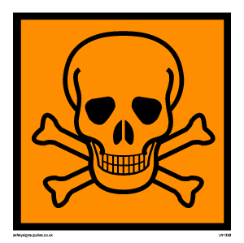

**CORROSIVE**

Corrosive substances can burn one’s skin. They can cause blindness in case they come into contact with the eyes. Example Of corrosive are sulphuric acid, hydrochloric acid, nitric acid, and concentrated alkalis e.g. Sodium hydroxide, potassium hydroxide, ammonium hydroxide.  
 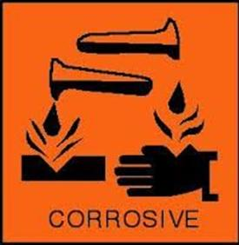  
  
 **FLAMMABLE**these are substances which can catch fire easily. The substances should never be brought near open flammable

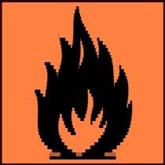

**OXIDANT**

These are chemical that can accelerate burning in the presence of an oxidizing agent, a small fire can be made bigger. Example in the heating of potassium permanganate mixed with saw dust

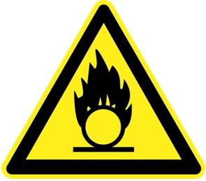

**EXPLOSIVE**

An explosion is a forceful rapid reaction, which involves throwing off of particles at high speed.  Chemicals carrying the sign of explosive may cause explosion if not handled carefully and according to the instruction.  
  
 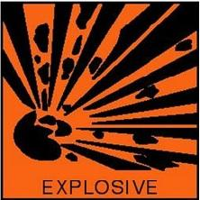

**HARMFUL/IRRITANT**

These are chemicals which can make you sick but it does not kill you, it can cause illness. This substance may not kill immediately, but may have effects after long exposure.  
  
  
 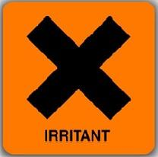

***7. Radioactive***

Radioactive substances give off harmful radiation which can cause damage to living tissues.

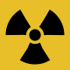

***8. Biohazards***

Biohazards are usually substances containing microbes or other factors which could cause diseases

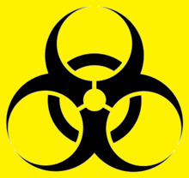

**BIOLOGY APPARATUS**

Biology apparatus are the tools and equipment needed in order to study Biological experiments effectively.

|  |  |  |
| --- | --- | --- |
| **APPARATUS** | | **USES** |
| 1. 1. | Hand lens | Used to magnify specimen/object. |
| 1. 2. | Sweep nets | Used to catch small flying organisms. E.g. Butter flies, housefly |
| 1. 3. | Fishing nets | For catching fish and aquatic animals |
| 1. 4. | Petri-dish | Is a shallow glass where specimen are put for close observation |
| 1. 5. | Mortar and pestle | Is small hard bowl used for crashing or grinding substances |
| 1. 6. | Crucible | Is a container in which substances are heated to very high temperature |
| 1. 7. | Thermometer | Used to measure temperature |
| 1. 8. | Dissecting Kit | Is a kit that contain all tools for making dissection of specimen |
| 1. 9. | Spirit – burner  Bunsen – burner | Used as a source of heat |
| 10. | Dropper | Used to add liquid during experiment |
| 11. | Spatula | Used for taking some substance from the container |
| 12. | Test tube holder | Used to hold test tube |
| 13. | Test tube | Used to hold  and heat chemicals |
| 14. | Test tube rack | Storing test tube |
| 15. | White tiles | Used to put specimen during experiment that involve color changes |
| 16. | Watch glass | Is a shallow dish that used as evaporating surface or cover for beaker |

**THE MICROSCOPE**

The microscope is an instrument used to magnify very small specimen so that can be seen clearly.

**THERE ARE TWO TYPES OF MICROSCOPE**

1) Light microscope

2) Electron microscope

Light microscope can magnify object up to 2000 times. This is the type of microscope that is commonly used in school laboratory.

Electron microscope can magnify a specimen up to 50000 times.

**PARTS OF A LIGHT MICROSCOPE AND THEIR FUNCTION**

|  |  |  |
| --- | --- | --- |
| 1) | Eye piece | Has a lens which magnify specimen |
| 2) | Body tube | Support the objective revolving nose piece |
| 3) | Rotating nose piece | Support the objective lens |
| 4) | Objective lens | Magnify the specimen under observation.It has three lenses, lower power, medium power and high power |
| 5) | Course adjustment knob | Raises or lowers the body tube in order to bring the image into focus |
| 6) | Arm | Support the body tube, knobs, stage diaphragm and mirror. It’s one of the part which  is held when moving the microscope |
| 7) | Fine adjustment | Raises or lowers the body tube in order to bring the image into sharp focus |
| 8) | Ocular tube | The tube allow light to pass straight from the objective lens to the eye piece lens |

**THE STRUCTURE OF THE LIGHT MICROSCOPE**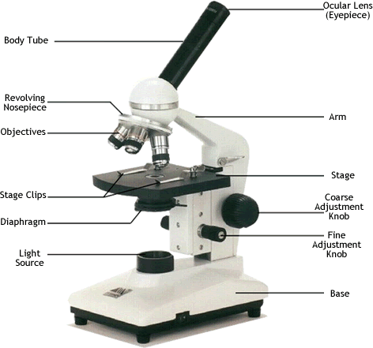

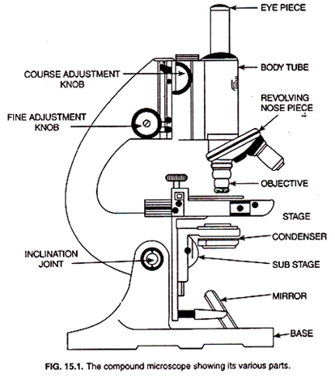

**How to use light Microscope**

1. Place the microscopes on the laboratory bench or table make sure it’s not near the edge.
2. Mount the specimen on a microscope slide, cover it with the cover slip.
3. Make sure that the low power objective lens is on line with the eyepiece lens.
4. Place the slide with the specimen on the stage.
5. While looking through the eyepiece, use your hand to adjust the stage so the light is directed at the specimen on the stage.
6. Adjust the course adjustment knob to bring the specimen focus.
7. Adjust the fine adjustment knob to bring the specimen into sharp focus.
8. Rotate the nose piece to a lighter power objective lens if you want to observe more details on the specimen.

**How to care for light Microscope**

1. Turn the adjustment knobs slowly, always start with course adjustment knob.
2. Always lift microscope using both hands, one hand holding the arm and other holding the base.
3. When not in use cover the microscope with clean cloth and store it in a dry, dust free space
4. Clean dirty lenses using lens tissue or soft cloth.
5. Don’t place the microscope at the edge of the table or bench as it could be knocked over.
6. When not in use for a long time remove the lenses and put them in desiccators.
7. Don’t touch the microscope with wet hands
8. Don’t touch the surface of the mirror of the lens with your fingers.
9. Lubricate moving parts regularly.
10. Always use a cover slip in order to protect the lens of the microscope from the substances in the specimen.
11. Remove the slides from the stage immediately after use.

**SAFETY IN OUR ENVIRONMENT**

**FIRST AID AND SAFETY**

First aid is an immediate assistance care given to a sick or injured person before getting professional medical help.

**ACCIDENT**

**Is** an action happen without your knowledge.

Or

Is an expected action that can cause death or injuries

**IMPORTANCE OF FIRST AID**

* It helps to save life.
* It helps to prevent the victim’s condition from becoming worse.
* It also promotes recovery.
* It helps reduce pain and suffering.
* It helps to reassure the victim/ to restore confidence to the victim.

**THE FIRST AID KIT**

The first aid kit is the small box which contains items that are for providing first aid. This box should be clearly labeled “first aid” and stored in a safe and easily accessible place for instance on a shelf, on the wall in a laboratory or in a staff room.

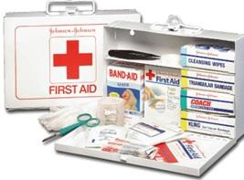

**COMPONENTS OF FIRST AID KIT AND THEIR USES**

|  |  |  |
| --- | --- | --- |
| **SN** | **ITEM** | **USE** |
| 1 | Plaster or adhesive bandage | Covering small wounds |
| 2 | Sterile gauze | Covering wounds to protect them from dirty and germs |
| 3 | Antiseptic | Cleaning wounds to kill germs |
| 4 | Soap | Washing hands/ wounds and equipment |
| 5 | pain killers | Relieving pain  Note: they should be placed regularly |
| 6 | scissor and razor blade | Cutting dressing materials |
| 7 | safety pins | Securing bandage |
| 8 | Bandages | Keeping dressing in place and immobilizing injured limbs |
| 9 | cotton wool | Cleaning and drying wounds |
| 10 | Thermometer | Taking body temperature |
| 11 | Disposable sterile gloves | Preventing direct contact with victim’s body fluids |
| 12 | petroleum jelly | Smoothing  chapped skin |
| 13 | Torch | As a source of light |
| 14 | Whistle | Blown to call for help |
| 15 | Spirits | To kill germs in wound |

 The following are First Aid procedures that can help people in various situations;

**Bee sting**

**Treatment**

When a person is stung by a bee sting remains on the skin.

* Remove the sting by scraping gently using a blunt object such as a plastic card
* Do not use your fingers or sharp object because this makes Bee sting to release more venom into the body.
* Wash the sting area with soap and water.
* Apply baking soda paste or salt water on the bee sting.
* The sting acidic baking soda/salt is base and it neutralizes the acid.
* Apply a cold compress to relieve pain and swelling

**Note:**

If a victim develops allergic reaction, take the person to hospital immediately.

**Electric shock**

This is a sudden painful feeling that somebody gets when electricity passes through the body. Electric shock is caused by touching or stepping an exposed naked electricity live cable

**Treatment**

Remove the patient from the source of the danger.

1. Switching off the electricity current
2. Protecting yourself with a dry insulation materials such as rubber gloves or wrap your hand in dry clothing
3. Loosen any light clothing around the neck, chest and waist
4. Start artificial respiration immediately if the victim is unconscious
5. Take the patient to the hospital immediately

**Shock**

This is the sudden violent disturbance of the mind or emotions.

**Causes of Shock**

* Bad news
* A frightening traumatic scene
* Severe illness
* Dehydration
* Severe allergic reaction
* Heavy bleeding inside the body

**Procedures**

1. Have the person lie down with his feet higher than his head. However if he/she has a severe head injury put him/her a half sitting position.
2. Stop any bleeding
3. If the person feels cold, cover him with a blanket.
4. If he/she is conscious and able to drink, give him/her sips of water or other soft drinks.
5. Keep calm and rescue the person

**Note:**

If the person is conscious, lay he/she on his/her side with head low lifted back and to one side. If they seem to be shocked pull his/her tongue forward with your finger. Do not give him/her anything by the mouth until become conscious.

**Wounds**

**Procedures**

1. First wash your hand with soap and water, then wash the abrasions gently and dry it
2. Apply some gentian violet solution (GV) to keep it clean and dry more quickly
3. When cleaning the wound be careful to clean all the dirty lift up and clean under any flaps of skin
4. After the wound has been cleaned, place a piece of clean gauze or cloth over the top

**Bleeding**

**a) Nose bleeding**

     Nose bleeding may occur as a result of

1. Blowing the nose too hard as a result of dried mucus
2. A punch direct to the nose from another person
3. High blood pressure
4. Air pressure changes

**Procedures**

* Sit quietly
* Blow the nose firmly for 10 minutes or until bleed stops. It is advised to breathe through mouth.
* If this does not control bleeding, pack the nostril a wrap of cotton. Leaving part of outside the nose if possible. First wet the cotton with hydrogen.

**Vomiting**

To vomit is to remove food from the stomach through the mouth. It can be caused by food poisoning, contaminated water, fever or excessive eating.

**Procedures**

The person should get adequate rest. Give lots of fluids make a  re-hydration drink by mixing 1 liter of clean water, 1.5 spoon of salt and 4 to 5 spoon of sugar.

**Muscle cramps and sprains**

1. **Sprains**

It’s possible to know whether a hand or foot is bruised, sprained or broken, it helps to have an x- ray. To release pain and swelling, keep the sprained part raised high. Put the ice, wrapped in a cloth or plastic bag or cold wet cloth over the swollen joint for 20 to 30 minutes. Once even hour (when the swelling is no longer getting worse, soak the sprain in hot water several times a day.

**Muscle cramps**

         Muscle cramp is sudden, involuntary and painful contraction of a single muscle or group of muscle. The cause of muscle cramps include

1. Poor coordination of the muscle during exercise
2. Cold
3. Excessive loss of salt and body fluids due to too much sweating ,severe diarrhea or persistent vomiting  (Dehydration)

**Procedures foot muscle cramps**

* Help the victim to stand
* When the first contraction is over, let the victim sit down.
* Straight on the victim knee and draw his or her foot firmly and steadily upward towards the shin
* Massage the muscle
* Get the medical help if the cramps do not stop

**POISONING**

**A poison** is any substance that causes harm if it’s swallowed, inhaled or absorbed into the body. -If the poison has been breathed in, move the person outside where there is plenty of fresh air, if the victim is not breathing start mouth breathing to move resuscitation.

-If the poison has been swallowed, give a glass of milk or water or both. This helps to dilute and neutralize the poison, don’t introduce vomiting if the poison is a corrosive. Introduce vomiting if the poison is none corrosive substances.

Vomiting can be induced by putting your finger in the victim’s throat or by making the victims gargle soap water or raw egg yolk, take the person to hospital immediately.  
  
**EXERCISE**

**WRITE TRUE OR FALSE**

1. You should induce vomiting, if a person has swallowed kerosene TRUE.
2. First aid helps to rescue the victim TRUE.
3. You should remove bee stings, using a needle FALSE.
4. Before taking a snake bite victim to hospital you must first capture the snake TRUE.
5. It is important to reduce the rate at which poison spread in the body TRUE.
6. You should move a victim of electric shock using a metal object FALSE.
7. A person who is nose bleeding should lie down TRUE.
8. We can use clean water, salt and sugar to make a re-hydration drink for person who has vomited TRUE.

**SAFETY AT HOME AND SCHOOL**

Many accidents occur in our schools as well as at home, children handicapped are more to get accidents. The common accidents at home and school including drowning poisoning, choking, cuts and scratches, falls, bites and electric shock.

**Common accidents and how to prevent them**

|  |  |
| --- | --- |
| **Accident** | **Preventing and safety and how to prevent them** |
| Fire burns and scalds | Switch off Bunsen burners and cookers which not in use |
| Drowning | -          Don’t go swimming alone  -          Use a bridge when crossing rivers and streams  -          Avoid going near water bodies when its dark  -          Don’t allow children to play near the water bodies  -          Cover or fence all pools of water in the home or school |
| Falls | -          always walk careful  -          avoid playing dangerous games like climbing trees and walls  -          put up signs to indicate where there stairs or steps  -          do not run unnecessarily  -          wipe spilled liquids on the floor immediately  -          do not leave fruits and vegetable peels on the floor |
| Poisoning | -          label all containers clearly  -          store all poisonous substances in a safe lockable place when not in            use |
| Choking | -          do not talk while eating  -          sit up right when eating or drinking  -          eat slowly and do not take part in eating competition  -          do not give children small objects to play with as they could put                  them in the mouth |
| Bites and stings | -          don’t irritate animals  -          stay away from beehives and wasp net  -          cut bushes and fall grasses that could have dangerous animals |
| Cuts and stretches | -          store sharp tools in the safe place  -          property dispose of broken glass and empty tins  -          do not walk bare foot outside  -          do not plant thorny bushes very near  -          do not give children sharp objects to play with |
| Electric shock | -          switch off electrical appliance that are being used  -          do not touch electrical equipment with your hands  -          ensure all electrical appliances are properly installed  -          do not push sharp object in to electric switch |

**WASTE DISPOSAL**

**Waste:** Refers to materials which are not needed.

**Waste disposal:** is the process of getting rid of waste materials

**TYPES OF WASTE**

We can classify waste according to its state

1. Solid waste
2. Liquid waste
3. Gaseous waste
4. Sludge waste

**Solid waste**

Is a hard waste material e.g. House hold, garbage, mining waste, plastic, paper, glass, scrap metal, waste, used tires, empty cans and construction waste.

**Liquid waste**

Liquid waste include urine, water from bathrooms, water from kitchen after washing utensils, liquid also come from industries e.g. chemical liquid waste.

**Gaseous waste**

This is waste in gaseous form for example ammonia, carbon dioxide and sulphur dioxide gases from materials and lead from petrol in motor vehicle. Gaseous waste is a major risk factor for both acute and chronic respiratory diseases.

**Sludge waste**

This is a thick soft and wet waste material usually a viscous material (flowing material) e.g. human waste, industrial waste which contain between 300/0 to 700/0 water. Waste from living things is biodegradable.

They can be decomposed by bacteria and other living organisms. E.g. food remain, paper and cotton clothes waste material such as plastics, glass, metal are non-biodegradable.

**Waste disposal**

Waste disposal refers to collection, transportation, processing, re-use and other activities that help us to get rid of waste. This helps to reduce adverse effects of waste on human health, animal’s health and environment.

**Basic principle of waste disposal**

The principles that can help us to better manage waste, these are:

1. **Reducing** amount of waste we produce, for example we do not have to buy plastic bags each time we go shop we can carry a woven basket instead.
2. **Re- using** items instead of throwing them away for instance we can use an empty margarine container to store sugar.
3. **Recycling** waste materials – some waste can be changed to other product for example, broken glass can be melt and use to make new glass bottles.

**Importance of waste disposal**

1. It helps to provide pleasing environment.
2. It eliminates or reduces bad air.
3. It minimizes the spread of infections and disease.
4. To prevent accident

**Methods of waste disposal  
  
         1. Burning**

Waste such as papers, plastic, carton – boxes, empty milk packet, bread wrappers, are burnt to ashes.

**2. Burying**

This is used to dispose inorganic refuse such as empty containers of insecticides, used torch batteries, broken bottles, pots, plates, cups and spoon.

Burying can take the following form

- **Pit latrine**

The sewage in pit is decayed by bacteria, when the pit is full it’s covered with soil and a new latrine is dug.

**-Tipping and landfills**

When car [truck] come and collect waste and take it to dumping site we called it tipping

Damping can be in form of a dump or landfill.

A landfill is place where solid waste buried in the ground.  
  
         **3. Animals feeds**

Organic refuse such as vegetable, fruit, potato and banana peelings, cabbage, and spinach leaves are feed to goats, sheep, cattle, poultry and also pigs. Bones are dried and ground into powder which is dog food.

**4. Compost manure**

After separating inorganic refuse from organic. A place of one meter deep is dug where the organic refuse is dumped to decompose, to keep away flies reduce smell and other health hazards, a thin layer of wood ashes and sock is used to cover the refuse. After the refuse decomposes, it’s used by farmer as compost manure which adds soil fertile.

    
       **5.** **Recycling**

To recycle is to turn waste materials into useful ones that can be used again. Plastic, glass, paper, metal and rubber are the items that can be recycled for example paper can be converted to tissue paper or news print paper, worn out tires can be retreated and re- used, plastic items old glass bottles can be crushed and made into new bottles.

        **6. Incinerating**

To incinerate is to burn something until it is completely destroyed. This process is carried out in an incinerator. Incinerator is usually done for hazardous material such as clinical waste.

**7. Garbage collection**

Garbage collection in urban areas is done by local authorities, local authorities provide refuse bins which are commonly placed at strategic places in towns. Garbage disposal are through landfill and incineration.

**THE EFFECTS OF POOR WASTE DISPOSAL**

1. Provide breeding places for disease causing organisms. E.g. empty container after rain become breeding places e.g. mosquito, cockroaches.
2. It causes air pollution result to respiratory diseases.
3. Can cause accident in home e.g. fresh peeling of fruits and vegetable, and potatoes on the floor can cause slippery and falls down breaking his/her leg, broken glass can cut people.
4. Organic wastes when decompose cause bad smell.
5. Causes epidemic diseases such as cholera and typhoid.
6. Can harm wildlife and domestic animals. E.g. when cow eat plastic bags, suffocate or block the digestive system and cause death.
7. Block of drainage system can cause flooding
8. Degrade the natural beauty of the environment.

**How to reduce waste product**

1. Use cloth instead of paper to wipe surface e.g. window and furniture. It’s much cheaper in the long run and reduces the amount of waste paper in the environment.
2. Invest in a set of cloth or woven shopping bags.
3. Buy rechargeable batteries and a battery charger instead of disposable batteries.
4. Collect and use plastic container to store food.
5. Initiate awareness campaigns in your community on the proper ways of disposing waste.
6. Use plastic that can be recycled or re – used and buy products made from recycled materials

             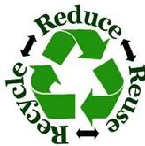

                             Symbol of recycled material

**Why waste product is a problem**

* People's bad habits for example dumping waste on foot paths, on the roadside and using excessive packaging for example wrapping a piece of candy to layers of plastic.
* Inadequate disposal facilities make waste disposal a problem.
* Failure by the local authorities to enforce effective punishment on those who failed to practice proper waste disposal.
* Poor infrastructure/ poor settlement planning render waste collection.

**Why increase of waste output now today?**

* Increase of population and new settlement.
* Increased consumption rate of more disposable packaging and foot waste.
* Technical advancement cause nuclear waste.

**HEALTH AND IMMUNITY**

**HEALTH AND IMMUNITY  
  
  
Health** - Is a state of physical, mental and social wellbeing.

Health can be affected by factors such as diet, Physical fitness, hygiene, stress, heredity, environment, medicine and immunity.

**Immunity** – Is the ability of the body to resist infections and disease. Immunity builds the body’s defense against infectious diseases. Through this, it helps us to remain healthy.

**TYPES OF IMMUNITY**

Basically there are two types of immunity namely:

1. Natural immunity
2. Artificial immunity

**(a) NATURAL IMMUNITY**

This is also referred to as immunity that an individual is born with. Natural immunity is divided into two types;

1. **Natural Active Immunity**

The body makes its own antibodies especially after an attack by disease causing micro-organism, adults have this kind of immunity.

1. **Natural Passive Immunity**

The body develops an immune system during development of the fetus (unborn baby) i.e. the antibodies from the mother pass to the fetus. After the baby is born the antibodies from the mother pass to the baby through sucking of the first milk (colostrum). This immunity last only for a few month.

**(b) ARTIFICIAL IMMUNITY**

This is the type of immunity an individual acquires in course of life time. This type of immunity is also referred to as acquired immunity.

Artificial immunity is of two parts;

1. **Artificial Active Immunity**

This immunity is acquired through immunization or vaccination using vaccine. A vaccine is a preparation containing dead or weaken disease cause organism, some vaccines are injected in the body while other are taken orally.

1. **Artificial Passive Immunity**

Artificial passive immunity is acquired when antibodies produced by individual are injected into a second individual.

This immunity provides an instant response but it is short term because the antibodies used are not the body’s own, so no more cells are created. Such immunity is used for potentially fatal diseases such as rabies and tetanus.

**Factors that can lead to lowering of body Immunity**

1. Lack of a proper balanced diet (poor nutrition)
2. Inhibitory effects of drug and chemical to the white blood cells.
3. In ability of the body to produce antibodies and the white blood cells
4. Lack of vaccination/immunization
5. Incomplete treatment
6. Genetic disorders
7. Extreme stress
8. Damage to the skin.
9. Destruction of immune system by pathogen e.g. HIV (Human immunodeficiency Virus.)

**PERSONAL HYGIENE AND GOOD MANNER**

Personal hygiene is the practice of keeping one self-clean all the time by maintaining a clean body from head to toe.

Or

Is practice of keeping one’s body and environment clean.

Personal hygiene also includes good grooming e.g. wearing well-fitting clothes good for you. To be able to maintain high standards of personal hygiene you must be having good manners.

**GOOD MANNER**

Is a kind of behavior that is socially accepted. It includes honesty, respect for others, politeness and helpfulness.

**PRINCIPAL OF PERSONAL HYGIENE**

1. Wash your body every day
2. Always wear clean clothes
3. Wash hands with soap and clean water after visiting the toilet and before eating.
4. Brush your teeth at least twice a day in the morning and before you sleep. Wash your mouth with clean water after eating.
5. Keep the environment clean. The environment include your bedroom, home, village, desk, classroom and school
6. Cover your mouth and nose with a clean handkerchief or tissue when you sneeze or cough
7. Keep your nails short and clean
8. Do not share handkerchief, towel and clothes especially underwear.
9. Wash your hair at least once a week comb it every day or keep it well plaited

     10. Change your bedding regularly

     11. Wear comfortable and well-fitting clothes

     12. Do not spit on the ground spit on handkerchief

     13. Avoiding picking your nose and biting your nails.

     14. Avoid touching other people’s hand fluids

     15. Relieve yourself in a clean toilet

**REQUIREMENT OF PERSONAL HYGIENE AND GOOD MANNER**

1. Listen to advice from people who have good personal hygiene and good manners and learn from them, good advice help us to improve ourselves**.**
2. Acquire the items needed to keep yourself and learn how to use your environment and those things include soap, towels, combs, brushes, basins and teeth brushes.

**IMPORTANCE OF PERSONAL HYGIENE AND GOOD MANNER**

* It provides good health. Ring worms and lice are spread because people do not practice personal hygiene.
* It makes a person acceptable and respectable in the society.
* It is important for personal appearance. A well groomed and well-mannered person is more attractive than a dirty and ill-mannered one.
* It makes us good role models for other people in the society.

**MAINTAINING PROPER PERSONAL HYGIENE DURING PUBERTY STAGE**

**PUBERTY**

Is the beginning of adolescence

Or

Is the stage when children begin to mature biologically and psychologically and their bodies become capable to reproduce.

It usually occurs between ages 10 and 14 in girls and ages between 12 and 16 in boys.

During this time the body develops secondary sexual characteristics which create difference between males and female. Puberty leads to adolescence.

**Adolescence** is transitional period between childhood and adulthood

**CHANGES IN GIRLS AT PUBERTY STAGE**

1. Body size increase rapidly
2. Breasts develops
3. Hair grows in the armpits and pubic area
4. Waist narrows and hips broaden.
5. Menstruation begins
6. Pimples may develop on the face
7. Sweat and oil glands become more active leading change in body
8. High pitched voice

**CHANGES IN BOYS AT PUBERTY STAGE**

1. Body size increase rapidly
2. Reproductive organs enlarge
3. Muscles grow
4. Hair grows on the face (beards) and in the armpits and pubic areas
5. Shoulder and chest broaden and voice deepens
6. Wet dreams begin and sperm production begins
7. Pimples may grow/develop on the face
8. Sweat and oil glands become more active leading to change the body odour.

- So it’s very important to maintain personal hygiene so as to prevent oduor and disease during puberty

- Also aim at being well behaved all the time by taking the following measures

**MEASURES**

* Resist negative peer pressure
* Get counseling from a reliable person
* Apologize if you hurt other people’s feelings
* Do not engage in sexual activities before marriage.
* Strive to be respectful to your elders even when you disagree with them.
* Get involved in positive extracurricular activities e.g. sports, debating and drama.
* **Avoid engage on**:

- Taking drug (drug abuse)

- Sexual affair

- Being rude to elders

**INFECTION AND DISEASE**

**Disease** is a condition that interferes with the normal functioning of the body. It can affect the whole body or only part of it

.

TYPES OF DISEASES.

There are two types of diseases

* Communicable diseases
* Non communicable diseases

**Communicable disease** is disease which can be spread from one person to another. They are caused by pathogen such us virus, bacteria, protozoan and fungi.

Example of communicable diseases is AIDS, Malaria, Cholera, Tuberculosis, Typhoid, Ring worms.

Vectors are organisms which carry pathogens e.g. fleas, mosquitoes, bee, tsetse fly. Communicable diseases are classified according to their occurrence.

**Types of communicable diseases**

1. EPIDEMIC DISEASES

These are outbreaks of communicable disease which affect a large number of people in a short period of time, e.g. Cholera, Typhoid, Meningitis and plague.

1. PANDEMIC DISEASES

These are communicable diseases which affect a whole country, continent or the whole words e.g. HIV/ AIDS

1. ENDEMIC DISEASES

These are communicable diseases which regularly occur in a particular area and is difficult to get rid of e.g. Malaria, gonorrhea, Syphilis, Bilharzia.

**Disease can be grouped also depending on the cause e.g.**

|  |  |  |
| --- | --- | --- |
| **SN** | **CAUSE** | **DISEASE e.g.** |
| 1 | Bacterial disease | Typhoid, Cholera, TB, Gonorrhea |
| 2 | Viral diseases | AIDS, Polio, measles, small pox, chicken pox. |
| 3 | Protozoan diseases | Amoeba dysentery, Trypanosomiasis (sleeping sickness), malaria |
| 4 | Fungal diseases | Ring worms, candidiasis, athletes |
| 5 | Genetic disease ( inherited diseases) | Hemophiliac, sickle cell, anemia, down syndrome, albinism |
| 6 | Worm diseases | Elephantiasis, bilharzia (schistosomiasis) |
| 7 | Hormonal diseases | Diabetes mellitus, diabetes inspidus |
| 8 | Malnutrition diseases | Kwashiorkor, obesity, marasmus, Goitre, Anaemia, Rickets |

**Diseases also can be grouped according made of transmission e.g.**

|  |  |  |
| --- | --- | --- |
|  | Air borne disease | Tuberculosis, common cold, influenza, whooping cough |
|  | Weather bone disease | Cholera, Typhoid fever, Schistosomiasis |
|  | Contaminated blood | HIV/AIDS, Malaria |
|  | Physical contract(contagious disease) | Ring worms, Scabies |

Routes through which disease causing agents enters our bodies are mouth, nose, penis, vagina, anus, skin, open wounds.

**COMMUNICABLE DISEASES.**

**TYPHOID.**

***Cause.***

This is a bacterial disease caused by bacterium called ***Salmonella typhi****.*

This bacterium mainly survives and grows in human beings and is expelled from the body through stool or urine. This bacterium damages the intestinal wall and the gall bladder.

**Symptom**

The symptoms of the disease include high fever and body aches.

Other symptoms include

* Fatigue,
* Abdominal pains,
* diarrhoea,
* Vomiting,
* Constipation.

Severity of the disease depends on the degree of contamination.

**Transmission.**

The disease spreads rapidly through ***contaminated water and food***, it is expelled from the body through the stool and urine. Typhoid germs is confined mostly in the gall bladder. ***Houseflies*** are potential **vectors** for spreading typhoid.

**Prevention.**

* Purification of water for domestic use**.**
* Proper community sanitation and general cleanliness.
* Proper use of latrines, ie. Wash his hands after visiting the toilet.
* Foods which are not cooked, e.g. fruits and salads should be washed thoroughly using clean water.
* People be educated on the spread and prevention of the disease.

**Treatment.**

This disease is transmitted using antibiotics e.g. chlroramphenical.

**PLAGUE.**

**Cause**

It is caused by bacillus bacterium called ***Pesturela pestis.***

***Symptoms.***

After a bite from an infected flea, the person develops fever, severe sickness and swelling of the lymph nodes near the flea bite. Normally the patient gets worse with the bleeding in many parts of the body. The illness becomes so severe such that patient dies within three to five days.

**Transmission**

This disease is primarily found in rats and rodents. The primary vector in transmission of plague bacterium is the ***rat***. The flea contracts the bacterium by biting an infected ***rodent***. Human beings contract the bacterium through the bite of a rodent flea. Eventually the infected bush or wild animals often do not die. However infected rats often die and the flies then look for a new host preferably a human being.

**Prevention.**

Aims at eliminating the flea population. It is difficult to eliminate rodents. Vaccination is in use to control plague.

**Treatment.**

When one is infected, antibiotics such as chloramphenical, tetracycline or streptomycin are administered.

**MENINGITIS.**

**Cause**

This is an infection of the mininges. Meninges are the membranes surrounding the brain and the spinal cord.

**Types of meningitis**.

Depending on the root cause of the disease there are three types of meningitis namely;

* + - 1. ***Bacterial Meningitis.*** This is caused by one of the most common bacteria such as pneumococci.
      2. ***Tuberculosis Meningitis,*** This is caused by tuberculosis bacterium, which invades the meninges.
      3. ***Viral meningitis,*** This is caused by one of the most common viruses. This virus infects the meninges.

**Symptoms.**

Bacterial meningitis is the most common type of meningitis. Symptoms include

* nausea,
* vomiting,
* headache,
* Fever and back pain.

These symptoms results to brain damage, restlessness and mental confusion.

**Transmission.**

Common potential sources of infection are sick persons and carriers of the disease. Pathogens are spread through by droplet infection.

**Prevention.**

* Patients suffering from the disease should be treated when isolated from the others.
* People who have made contacts with meningitis patients should be treaded with antibiotics.
* In case of an outbreak overcrowding should be avoided.

**Treatment.**

Early treatment is absolutely necessary especially for bacterial meningitis, which responds well to **antibiotics**. Viral meningitis does not respond well to antibiotics. However, it heals progressively with no treatment.

**CHOLERA**

**Cause.**

This is a bacterial disease. It is cause by a bacterium known as ***Vibrio cholerae***. Cholera is an endemic disease in most of the Third world countries. The disease strikes areas where there are poor sanitary conditions and the water is not well treated.

**Symptoms.**

Severe watery diarrhoea, ie. Rice water stool.

Abnormal pain.

Very light urine or no urine at all.

Vomiting.

General body weakness.

Blood pressure is very low.

Breathing is fast and shallow.

The patient loses weight rapidly.

Patient develops wrinkled skin and sunken eyes because of dehydration.

**Transmission.**

Cholera is both a ***water and food borne*** disease. Hence is transmitted by contaminated food and water. Cholera epidemics are common in refugee camps, prisons and during floods when water supply systems break down and unhygienic conditions prevail.

**Prevention.**

* Food should be well cooked. Vibrio cholerae dies at 56 0C.
* Drinking water should be boiled.
* People be educated on the spread and prevention of the disease.
* Proper storage of food.
* Eat warm food.
* Avoid eating raw vegetable.
* Proper use of latrines.
* Wash hands after visiting toilets.
* Wash hand before and after eating.
* Affected people be isolated/quarantine.

During epidemics or when one is going to an infested area must be vaccinated.

**Effect**

* Dehydration.
* Death.

**Treatment.**

* This disease is treated using antibiotics such as tetracycline.
* Treating and preventing dehydration help in curing cholera.

**MALARIA.**

**Cause**

Malaria is a **protozoan** disease caused by a parasite called **Plasmodium.**

There are several species of plasmodium, but only four are known to affect humans. ie. Plasmodium malariae/falciparum/vivax/ovale.

**Symptoms.**

High fever, and sometimes with heavy sweating.

Frontal headache.

Pain in the joints.

General body weakness

Lack of appetite.

Sometimes nausea and vomiting.

Chill with violent shivering.

**Transmission.**

The parasitic protozoa are transmitted from a sick person to a healthy person by a **female anopheles** **mosquito.**

Rarely transmission can occur through transfusion of infected blood by malaria parasites from a sick person to a healthy person.

Incubation period in humans is normally about two weeks.

**Prevention and Control.**

* 1. Drain marshes or remove stagnant water, ie. To prevent egg laying by the female anopheles mosquito.
  2. Spray light oils containing insecticide on water that can not be drained.
  3. Introduce fish eating mosquito into the stagnant water to feed on larvae and pupae.
  4. Spray walls of houses with long-lasting insecticides.
  5. Fill up potholes and shallow pools.
  6. Bury all containers, which can hold water.
  7. Clear any bush around the house.
  8. Sleep under a mosquito net impregnated with permathrin, or NGAO which both repel and kill mosquitoes.
  9. Screen the windows with mosquito proof wire mesh.
  10. Quarantine or isolate those who become diseased away from other people.
  11. Preventive medicines are taken regularly to kill the parasites on entry, eg. Mepacrine.
  12. Use of mosquito repellant ointments, ie. Mospel.

**Treatment.**

-Quinine and chloroquine are the oldest drugs used to treat malaria. Health authorities in some countries have banned these drugs, as plasmodium seems to have developed resistance to these drugs.

-However there are drugs like fansidar, metakelfin, arinate, ect, that attacks the parasite in the blood cells as well as in the liver cells.

**SCHISTOSOMIASIS.**

The disease is also called **Bilharzia or Snail fever.**

**Cause.**

Bilharziasis is a worm disease caused by small worms called Schistosomes. Schistosomes live in blood in the veins of the pelvic organs. Schstosoma is also known as the blood fluke.

*The types of schistosomes.*

* + - * 1. ***Shcistosma haematobium***, causes urinary bilharzia.
        2. ***Shcistosma japonicum***, affects large and small intestine
        3. ***Shcistosma mansoni***, causes intestinal bilharzia.

**Symptoms.**

The symptoms of the disease are either passing out urine mixed with blood in the case of urinary bilharzia or passing out faeces stained with blood in the case of intestinal bilharzia.

*Accompanying these symptoms are;*

General body weakness.

Irritation of urinary bladder or large intestine.

Fever, cough and abdominal pain.

Loss of appetite.

Sometimes there is loss of weight.

Patient becomes so anaemic.

The spleen and the liver become very large.

Fluid collects in the abdomen and in the legs, resulting in a condition known as ***oedema***.

**Transmission.**

Eggs are passed out of the patient through urine or stool.

When these eggs enter into water they become worms called *Miracidia*. The worms swim and find an intermediate host, the Snail in which they can grow.

Miracidia leaves the snail for another host, the human being, and here they become*Cercariae.*

The worms enter human through skin or mucous membrane of the mouth.

The cercariae travel around the body and settle in the pelvic veins where they develop into adult ***schistosome worms***.

**Control and prevention.**

Avoid contact with water, which has schistosome.

Prevent growth of snails: Drain stagnant water.

Introduce ducts that feed on mollusca

Using molluscides.

Toilets should be used all the time and properly.

Health education should be taught.

Eradicating the intermediate host.

Kill the parasites in the bodies of host or reservoir.

Boiling and chlorination of water for domestic use.

**Treatment**

Praziquatel: effective for all species and have little side effect.

Niridazole: effective on one species and have unpleasant side effects.

**EBOLA**

**Origin**

Ebola was discovered in late 1970s when an unknown outbreak killed more than 500 people in Zaire-DRC. Ebola is a name of a river where the outbreak was first cited.

**Cause.**

Ebola is a viral disease.

**Symptoms.**

* 1. Diarrhoea
  2. Haemorrhagic fever.
  3. Skin bruises and blisters.
  4. Blood oozes from everybody opening.
  5. Vomiting of the already disintegrated internal tissues.
  6. Uncontrollable bleeding.

**Transmission.**

Ebola is a contagious disease that spreads through contact of contaminated body secretions.

**Prevention and cure.**

1. Ebola has no vaccine or cure. Is more dangerous than AIDS.
2. Simple sanitary measures such as using gloves and protective masks and clothing in hospitals can help to contain the disease.
3. Quarantine must be imposed whenever there is an outbreak of Ebola.

**SEXUALLY TRANSMITTED DISEASES (STD’S)**

These are infections, which are transmitted mainly through sexual contact during sexual intercourse. They are also referred to as ***Venereal diseases.*** Examples are; syphilis, Gonorrhoea, Chlamydia, Chanchroid and Granuloma, Candidiasis, Vaginosis, Genital Herpes, Hepatitis B, HIV/AIDS, and Trichomoniasis.

**GONORRHOEA**

This disease is caused by the gonococcus bacterium called ***Neisseria gonorrhoea.*** The bacterium infects the urethra in males and vaginal tract in females.

**Transmission**

Through sexual intercourse

may be transmitted to eyes by a towel

The disease may affect baby’s eyes at birth. If they pass through an infected birth canal.

It can also infect the throat if infected genitals are kissed.

**Symptoms in men**

* Swelling burning and pain in the reproductive tracts
* Pain or difficulty with urination.
* Drops of pus from the penis.
* Sometimes there is painful swelling of testicles.
* Rash or sores all over the body.

**Symptoms in women.**

* Menstrual problems
* Pain in the lower abdomen.
* Urinary problems
* Yellow discharge from the vagina.

**Effects**

1. It can cause sterility
2. It can cause blindness
3. It rarely causes death

**Control.**

* Avoid unsafe sex, ie. Sex before or outside marriage.
* Pregnant women should be checked and treated if any.

**Treatment**

* Effectively treated using antibiotics like, Kanamycin, Streptomycin.

**SYPHILIS**

The disease is caused by bacteria called ***treponema pallidum***.

**Transmission**

i. Through sexual intercourse and sometimes through open sore (fracture)

* + 1. From mother to foetus during pregnancy as the bacterium passes through the placenta.
    2. From mother to child during birth.

**Symptoms**

***Syphilis has three stages.***

1. First Stage or Primary Stage: development ***chancre*** i.e. a shiny and bright ulcer like a pimple, blister or an open sore on the site of the infection. This may last for about six weeks
2. Second stage or Secondary stage: If untreated after six weeks there may be development of skin rashes, sore throat, mild fever, headache mouth sore and ulcers on lips, swollen joints, loss of weight and appetite.
3. Third Stage or Tertiary Stage: this is called latent or quiet stage. What happens? Tumor may built up in the skin and visceral (internal) organs like heart, liver and can cause death.

**Prevention:**

1. Avoid irresponsible sexual behavior. ie. To have healthy sexual relations. Avoid sex with strange person
2. to get medical help and treatment immediately after the symptoms

**Treatment.**

Antibiotics like benzathine penicillin or tetracycline.

**GENITAL HERPES.**

This is a painful skin infection caused by a virus called ***Herpes simplex***.

**Symptoms**.

* 1. One or more small painful blisters, like drops of water on the skin, appear on the sex organs, penis, vagina, anus, buttock and thighs.
  2. Blisters burst and form open sore.
  3. The sores dry up and become scabs.
  4. Herpes can also appear on the mouth as a result of oral sex.
  5. The infection can spread to eyes if a person rubs them after touching the sores.

**Transmission.**

Through sexual intercourse.

**Treatment**.

Currently there is no medicine that cures herpes. Keep the area clean. Never have sex while the blisters or sores are present.

Wash hand more often and try not to touch the sores.

**CHANCROID**

Is a bacterium infection.

**Symptoms.**

* + - * 1. Soft painful sores on the genitals or anus.
        2. Enlarged lymph nodes may develop in the groin.

**Treatment.**

|Give co-tremoxazole or erynthromycin for 7 days. Take erythromycin after meals to avoid stomach upset.

**Secondary Effects of Sexually Transmitted disease.**

Infertility/sterility.

Pelvic inflammatory diseases.

Ectopic pregnancies.

Sepsis which can lead to death.

Cervical cancer.

Premature birth, abortion and stillbirths.

Blindness of the foetus.

**HIV/AIDS**

**AIDS** stands for ***Acquired Immune Deficiency Syndrome***.

**HIV** stands for ***Human Immunodeficiency Virus.***

**Cause.**

AIDS is a viral infection caused by a strain of a virus called HIV. The virus is mainly found in the body fluids such as blood, semen and vaginal secretions. Also traces of HIV have been found in the sweat, saliva and tears.

**Transmission.**

* 1. By having sexual intercourse with an infected person.
  2. By transfusion of infected blood.
  3. Mother to Baby: -By birth, from an infected mother to her unborn baby.

-Contact with vaginal secretion during birth.

-Breast feeding.

* 1. By use of unsterilized surgical and skin piercing tools, eg. Needles, pair of scissors. etc.

**Stages of HIV.**

Window stage, the HIV virus inters the body.

Incubation period, the virus is multiplying in the body.

Symptomatic period, signs and symptoms start to show.

Full blown period, the immune system is completely destroyed.

**Effects of HIV on White blood cells.**

HIV replicates in particular type of white blood cell called ***T4 Cell***. The cell usually helps the ***Killer T Cell*** (*Helper T Cell*) to fight pathogens. The virus destroys the T4 Cell. Hence immune system breaks down and the person becomes vulnerable to variety of diseases.

**Sign and Symptoms.**

* + - * 1. Chronic diarrhoea for more than a month.
        2. Eventual loss of weight, up to 10%.
        3. Constant and persistent severe cough for longer than a month.
        4. Skin infection, rashes and skin cancer.
        5. Inflammation of the lymph nodes.
        6. Advance stage: Mental confusion and eye problems.

**Effects of HIV on Human body immunity.**

HIV weakens the immune system by entering into the white blood cells (lymphocytes).

Patients with AIDS are prone or susceptible to **opportunistic infections**, like;

Tuberculosis,

severe diarrhoea,

skin cancer,

Pneumonia.

**Diseases Associated with AIDS.**

Brain infection, mental confusion and severe headache.

Cancerous cases, skin cancer.

Chest infections, pneumonia and tuberculosis.

Gut infections, chronic diarhoea.

**Prevention and Control**

1. Avoid promiscuous sex, ie. Abstain, being faithful to one partner or use Condoms.
2. Avoid transfusion of blood unless screened for HIV virus.
3. Avoid sharing unsterilized surgical and skin piercing tools.
4. Health and sex education should be given to people.
5. Pregnant mothers should visit special clinic to protect their unborn children.
6. Avoid risk behaviour: ie. Homosexuality, prostitution, alcoholism and drug abuse.
7. Patients should take anti-retroviral drugs (ARVs) which prolong their life span.

**Treatment.**

At the moment there is no treatment.

However several discoveries for drugs have been reported but none has been confirmed as being 100% effective.

**Care of PLWHA (People living with HIV/AIDS)**

These people need special care as they fear death, feel lonely and bad about the situation.

* + 1. Keep wounds clean and covered
    2. Do not share sharp things.
    3. Wear gloves when washing hi/her beddings.
    4. Keep his/her beddings and clothings clean.
    5. Keep patient clean, ie. Dispose his/her faeces, urine, vomit, sweat.
    6. Give extra fluid to drink.
    7. Give recommended good food, ie. Balanced diet.
    8. Do not let patient smoke or use alcohol.
    9. Offer enough rest and good sleep/
    10. Offer moderate exercises.
    11. Give words of wisdom, hope and success.
    12. Never discriminate or stigmatize the patient.
    13. Treat opportunistic diseases.

**RISKY SITUATION, BEHAVIOUR AND PRACTICES**

These are activities and situation that put us at greater risk of being infected with STIS, STDS and HIV these include: –

* Transfusion using unscreened blood
* Drinking alcohol, smoking using other drugs such as bangi, heroin and cocaine
* Having immoral friends who influence to use drug abuse, engage in sex earlier
* Having many sexual partners having unprotected sex
* Sharing sharp object and toothbrushes.

**HOW TO AVOID RISKY PRACTICES BEHAVIOUR AND SITUATION**

* Abstain from sex before marriage.
* Be faithful to one sexual partner.
* Do not share sharp object.
* Avoid drug abuse, learn to resist peer pressure.
* Do not accept gifts or favors from members opposite sex
* Avoid staying in dark/ privacy area during night alone
* Avoid risk place e.g. bars, night club, casino

**IMPORTANCE OF HEALTH CARE FOR STIS, STDS AND OPPORTUNISTIC DISEASES**

* Discrimination leads to depression, loneliness, loss of performance at work and school.
* Early testing and treatment will help to treat or slow down the development of the infection or disease in its early stage
* Proper treatment can save life and prevent long term effects such as infertility
* Healthcare professionals can give appropriate counseling on how to manage the infections
* Testing gives peace of mind
* Proper health care reduces the chance of infecting other people.

**CELL STRUCTURE AND ORGANIZATION**

**The Cell** is a basic unit of life.

* All living things are composed of cells which carry out the process that make the organism lives entity.
* All cells are basically the same in chemical composition. All life processes take place in the cells.
* Some organisms are made up of many cells and are called multicellular organisms e.g. man, pine tree, locust. Others have one cell e.g. Amoeba, they are called unicellular organisms.
* All cells are microscopic, its membrane bound it has structures that are site for chemical reaction called organism.
* They have ability to replicate, since they contain the genetic materials. So these are characteristics of cell.

**TYPES OF CELLS**

There are two basic types of cells

* **Prokaryotic cells**
* **Eukaryotic cells**

**Prokaryotic cells** are found in organisms which do not have membrane bound organelles, they do not have nucleus.

Prokaryotes are mostly single celled organisms such as bacteria and blue green bacteria.

DIAGRAM OF BACTERIA

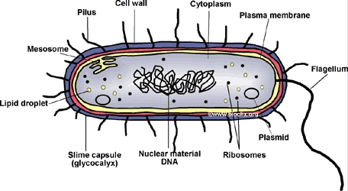

CHARACTERISTICS OF PROKARYOTIC CELL

* They do not have nucleus
* They are unicellular organism
* Lack an organized nucleus and other membrane-bound organelles
* DNA is found in a central part of the cell called the nucleoid.
* The cell wall of a prokaryote acts as an extra layer of protection, helps maintain cell shape, and prevents dehydration.

**Eukaryotic cells** are cells which have a membrane bound nucleus. They contain specialized membrane bound organelles

Eukaryotic cells can be found in a single celled organism such as Amoeba or they can be found in multicellular organisms.

**CHARACTERISTICS OF EUKARYOTIC CELL**

* They have a “true” nucleus, membrane-bound organelles, and rod-shaped chromosomes.
* They are multicellular organism
* The nucleus houses the cell’s DNA and directs the synthesis of proteins and ribosomes.
* Mitochondria are responsible for ATP production; the endoplasmic reticulum modifies proteins and synthesizes lipids; and the Golgi apparatus is where the sorting of lipids and proteins takes place.

**ANIMAL AND PLANT CELLS**

Both animals and plants differ in structure and function in order to be able to meet the requirement of each organism.

**Animal cell**

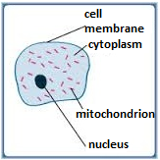

**Plant cell**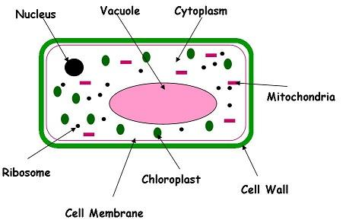

**FUNCTION OF THE PARTS OF ANIMAL CELL** **1. CELL MEMBRANE**

* Is also known as plasma membrane or plasma lemma.
* Is thin layer that encloses the whole cell

**Function of cell membrane**

* Communicate with other cells.
* It allows selective movement of substances into and out of the cell. It is said to be a selectively permeable membrane or differential membrane
* It encloses the contents of the cell.

**2.** **CYTOPLASM**

This is jelly- like substance made up of water and dissolved chemical substances.

**Function of cytoplasm**

* It act as the site for many chemical reactions in the cell.
* Cell organelles such as the vacuoles, nucleus and mitochondria are suspended in the cytoplasm.
* Act as the food of the cell

The movement of cytoplasm is known as cytoplasmic stream

**3. NUCLEUS**

This is a round or oval organelle suspended in the cytoplasm. The nucleus is made up of nucleolus and fluid called nucleoplasm. It is surrounded by a membrane called the nuclear membrane.

**Functions of nucleus**

* To determine the chemical processes that take place in the cell.
* To control the functions of all parts of the cell
* To determine the cell size, shape and function
* To determine the hereditary characteristic of a cell

**FUNCTION OF THE PARTS OF PLANT CELL**

            1.**CELL WALL**

* This is a strong covering made of cellulose.
* The cell wall is fully permeable. It allows the passage of water and minerals, gases (freely permeable).
* Protects and gives the cell a definite shape

2. **CHLOROPLAST**

* They are sites of photosynthesis
* It contains green pigment called chlorophyll.
* Chlorophyll absorbs the light energy needed for photosynthesis

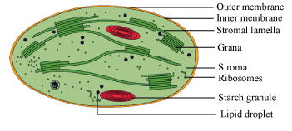

3.**VACUOLE**

Vacuoles maintain a balance between water molecules and solute molecules in the cell; contain color pigments, which give color to flower.

The fluid inside vacuole is known as cell sap.

4.**MITOCHONDRIA**

The function of mitochondria is the site for respiration, reactions which yield energy for the cell.

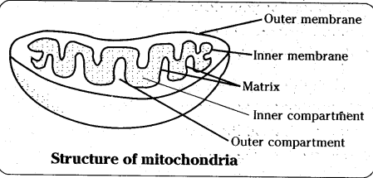

5.**RIBOSOMES**

 This is the site of protein synthesis.

**SIMILARITIES BETWEEN PLANT AND ANIMAL CELL**

* Both have cell membrane.
* Both have cytoplasm.
* Both have nucleus.
* Both have vacuoles, ribosomes and mitochondria.

**Differences between plant cell and animal cell**

|  |  |
| --- | --- |
| **Plant cell** | **Animal cell** |
| Has a cell wall | No cell wall |
| Has chloroplast | Lacks chloroplast |
| Have definite shape | Have no definite shape |
| Has a large permanent vacuole | Has small temporary vacuole |
| They are normally large | They are usually smaller |
| They store oil, proteins, starch | They store fats and glycogen |

**CELL DIFFERENTIATION**

**Cell differentiation** refers to the way cells are adapted so that they can carry out function efficiently

* Cells have different functions and features that make them better suited to carry out these functions. This is called cell differentiation.
* Most living things are made up of many structurally and physiologically adapted different kinds of cells.
* These cells perform specific function and this is referred to as cell specialization.

**TISSUE**

A tissue is a group of similar cells performing the same function. Basically there are two types of tissue.

Animal tissue e.g. epithelial tissue, muscular tissue, blood tissue, nerve tissue, skin tissue.

Plant tissue e.g. meristematic tissue, parenchyma tissue, collenchyma tissue, vascular tissue (xylem tissue, phloem tissue).

**ORGAN**

An organ is a functional unit formed by a group of specialized tissue.

**Animal organ:** - heart, kidney, liver, brain, tang, stomach

**Plant organ:** - roots, leavers, flower, stem

**SYSTEM**

System is made up of organs that work together to perform a certain function.

Examples of system are Respiratory system, digestive system, reproductive system, hormonal system, skeletal system and blood circulatory system, nervous system.

**ORGANISM**

An organism is the individual living organism e.g. Animal and Plant.

An organism is made up of different systems working together therefore there is special

Tissue  
  
  
C:\thlb\cr\tz\__i__images__i__\img141.jpg

**Importance of cell differentiation**

* Cell differentiations leads to division of labour.
* Division of labour means each cell does a specific function. This helps the body to carry out all life processes at the same time and more efficiently.
* To achieve this, cells must become specialized to carry out special functions.

**\* Study more about specialized cell for different function e.g.**

**White blood cell (WBC)** can change their shape to engulf and destroy harmful pathogen.

**Red blood cell (RBC)** for transporting oxygen (they are biconcave and lack nucleus)

**Sperm cell –** Fertilizes the female egg (have tails for swim pointed head for easy penetration)

**Root hair cells –** for absorb water and mineral salts (have extended portion helps to increase surface area for absorption)

**Guard cell** – control open and close of stomach (the inner wall is thinker than outer)

**Palisade cell** – makes it to expand irregularly

**CLASSIFICATION OF LIVING THINGS**

**Classification** is a grouping of organisms based on their similarities and differences.

Organisms that are similar are placed in one group.

Or

**Classification** is a branch of biology that deals with the grouping of living organisms according to their structure, way of life and origin.

These similarities could be in terms of ancestry structure or the way they carry out life processes such as feeding and reproduction.

**TAXONOMY**

It is a branch of biology that deals with classifying organisms.

**TAXONOMIST**

A person (biologist) who studies about classification.

**TAXON**

Is any named established group in the ranks of classification.

**IMPORTANCE OF CLASSIFYING LIVINGTHINGS**

1. There are millions of livings things in the world, grouping them make it easy to study and identify them.
2. Scientific names enable scientist to identify organisms easily, no matter which part of the world they are in.
3. It easier to study organisms in a group, because the members of a group have many things in common.
4. Classification enables scientists to make predictions.
5. It provides an organized system in which newly identified similar organism can be fitted in future
6. It helps man arrange the information about living organisms in an orderly manner to avoid confusion.

**CLASSIFICATION SYSTEM**

There are two main types of biological classification namely: -

1. Artificial classification
2. Natural classification

**ARTIFICIAL CLASSIFICATION**

Artificial classification system is grouping of organism according to observable features. For example presence of legs or wings based on bees, birds and bats would be grouped together because they have wings. Snakes, earth worm and snails would also be grouped together because they do not have legs.

Artificial classification also involves classifying organisms according to their size how they move, where they live or what they eat.

**Advantage of artificial classification**

* It straight forward and easy to use
* It can be done very fast
* Artificial classification is less costly than natural.

**Disadvantage of artificial classification**

-Some organisms that are dissimilar in their internal make up are grouped together because of the resemblance of their external features.

-Some similar organisms are put in different groups because they do not have a lot of physical remembrance.

-It is less accurate because it uses only few observable characteristics.

-Artificial classification depends a lot on what the scientist is interested in therefore it varies from person to person.

**NATURAL CLASSIFICATION**

              In this system classification is based on evolutionary relationship and presence of large number of common and similar characteristics feature that show homology and analogy structure.  
     
     **Homologous structures**: Are the structure having the same origin but perform different function. Eg, Forelimbs of whale and forelimbs of man.  
   **Analogous structure**; Are structure having different origin but perform the same function. Eg, Wings of birds and wings of insect

**Advantage of natural classification**

1. It gives a lot of information of living things
2. It is most accurate
3. It is universal
4. It avoids confusion

**Disadvantage of natural classification**

1. It requires a lot of time
2. It needs high skills
3. It is difficult to classify
4. It is expensive
5. It is not stable.

**Difference between artificial and natural classification**

1. Artificial is not accurate and natural is most accurate
2. Artificial is cheap while natural is expensive
3. Artificial classify living organism according to the external features while natural classification classify living organism according to the internal features.
4. Artificial does not require scientific skills while natural classification requires scientific skills and knowledge.

**MAJOR GROUP OF LIVING ORGANISM**

There are five major groups of living organism

1. Kingdom animalia eg. Cow, cockroach
2. Kingdom plantae eg. Maize tree, peas
3. Kingdom monera eg. Bacteria
4. Kingdom protoctista eg. Amoeba
5. Kingdom Fungi eg. yeast

**RANKS OF CLASSIFICATION**

1. Kingdom
2. Phylum or Division
3. Class
4. Order
5. Family
6. Genus

-Kingdom has a greatest variety of organism

-At kingdom level, organism shows few features in common as you move down the rank each unit has lesser and lesser organisms and the members of each unit have more and more features in common.

In table below some few common organisms have been classified from kingdom to species level. This should guide you in classifying other organisms.

**CLASSIFICATION OF SOME COMMON ORGANISM**

|  |  |  |  |  |
| --- | --- | --- | --- | --- |
| TAXONOMY UNIT | HUMAN BEING | DOG | MAIZE PLANT | EUCALYPTUS TREE |
| Kingdom | Animalia | Animalia | Plantae | Plantae |
| Phylum or division | Chordata | Chordata | Spermatophyta | Magnoliophyta |
| Class | Mammalia | Mammalia | Argiospermae | Magnoliopsida |
| Order | Enirate | Carnivore | Graminales | Myrtalesa |
| Family | Hominidae | Canidae | Graminales | Myrtaceae |
| Genus | Homo | Canis | Zea | Eucalyptus |
| Species | Sapiens | Familiars | Mays | Regnans |
| Scientific name | Homo sapiens | Canis familiaris | Zeamays | Eurcalyptus regnans |

**KINGDOM**

For example human being and donkey

Kingdom Animalia is subdivided into phyla or phylum in singular

Kingdom Plantae subdivided into division, The phyla or division are further subdivided into class, each classes is subdivided into orders every order is subdivided into families and families are subdivided into genera (genus in singular)

A genus is subdivided into species. Kingdom, phylum, divisions, classes, orders, families, genera and species are ranks of classification and are called units or taxa.

The following flow chart shows how kingdom Plantae and kingdom Animalia are subdivided

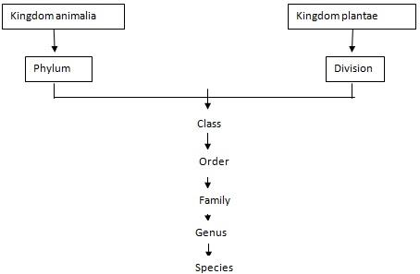

**BINOMIAL NOMENCLATURE**

Nomenclature is a system of naming organism where by every name is made up of two Latin words.

This system was divided into two parts

The first part of the name represents the genus it is also called the genetic name.

The second part of the name represents the species it is also called the specific names

For example: The specific name of human being is Homo sapiens. Homo is generic name and sapiens is the specific name. The following rules are observed when writing scientific names.

1. The generic name is written before the specific name
2. The generic name must start with capital letter.
3. The specific name is written in small letter
4. In publisher document such as books scientific name is written in italics eg, Zea mays and Homo sapiens when hand written or typed the names should be underlined.

**SCIENTIFIC NAMES OF SOME COMMON ORGANISMS**

|  |  |
| --- | --- |
| **COMMON NAME** | **SCIENTIFIC NAME** |
| Coconut plant | Cocos nucifera |
| Mango tree | Mangifera Indica |
| Garlic plant | Allium sativum |
| Pea plant | Pisum sativum |
| Domestic cat | Felis catus |
| Housefly | Musca domestica |
| Lion | Panthera leo |
| Donkey | Equus asinus |

**VIRUSES**

A virus is an extremely small microorganism.

It is smaller than a living cell. A virus is not a cell

The study of viruses is called virology

Different types of viruses:

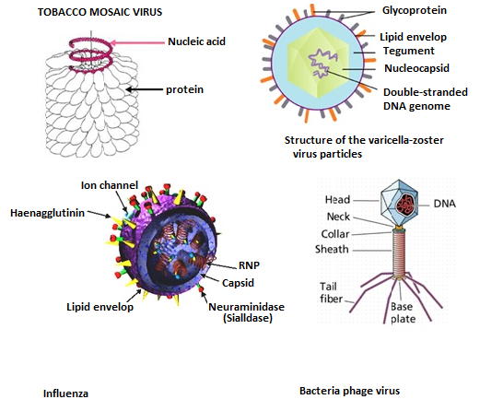

**STRUCTURE OF VIRUSES**

A virus has a very simple structure consisting of genetic material with a protein shell. The protein shell is called a **capsid**. Viruses do not have a nucleus or complex membrane cell organelles. Some viruses have viral envelopes.

There are membranes enclosing the host cell.

Viruses cannot reproduce its own. It must attack a host cell and uses the material in that cell to reproduce.

This is called oblige parasitism.

**CHARACTERISTICS OF VIRUSES**

* Viruses do not grow, feed, excrete or respire. Viruses exist in a dormant state when outside a host cell.

        They show no signs of life; they can stay that way for months or even years.

* A virus particle outside a host cell is called a virion. The virion attacks and cause diseases.
* Viruses are host specific, this means that a certain type of virus only attacks a certain host for example. The viruses affect only certain type of white blood cell in human being.

**Advantages of viruses**

-Virus is important in the study of cellular and molecular biology. They are used by scientist to manipulate and investigate the function of cell.

-Some viruses are used to make vaccine. For example, the first vaccine against small pox was a small dose of virus that causes cow pox, which is milder infection. On recovering from cow pox, the body had antibodies that could resist both cow pox and small pox.

-Bacteria phages are viruses that attack bacteria they help in attacking bacterial infections and diseases.

**Disadvantage of virus**

1. Viruses are pathogens, they cause disease and infections such as rabies, muscles, chickenpox and polio also they destroy living cell.
2. They can reproduce very fast, leading to large scale epidemics.
3. Viruses can attach themselves often and this become difficult to destroy for example there are many different types of viruses that cause the common cold and influenza. This makes it difficult to develop vaccines or cures for these infections.

**KINGDOM MONERA**

This kingdom monera consists of bacteria and blue green bacteria. The scientific study of bacteria is called bacteriology.

**CHARACTERISTICS OF BACTERIA**

1. They are prokaryotic.
2. They are unicellular, some bacteria stick together to form chain or clusters called colonies.
3. Some are free – living while others are parasites or saprophytes. Free living bacteria are those which exist on their own for example in sewage or soil. Parasitic bacteria are those which live on other organism and get their food from them for example in human beings and animals.

Saprophytes bacteria grow and get their food from died organic matter.

1. Free living bacteria have flagella for movement.
2. Bacteria have a slimy outer layer. This layer helps to protect the bacteria
3. They produce either asexually by binary fission or through spores or sexually through conjugation.
4. Bacteria occur in various shapes.

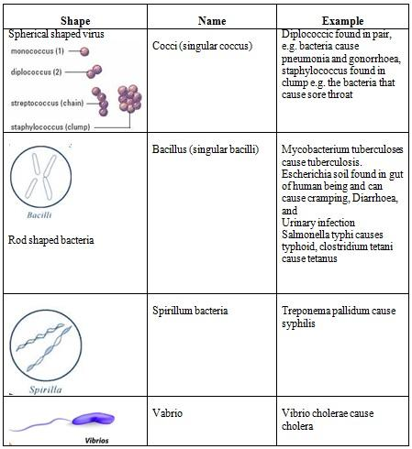  
  
  
A bacterium consists of nucleic materials suspended in the cytoplasm. (no nucleus)

The cytoplasm is enclosed by fold cell membrane; a cell wall and slim layer enclose the cell membrane.  
  
  
  
  
           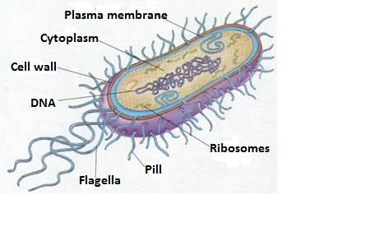

**Basic structure of bacteria**

**Pathogenic bacteria**

These are bacteria that can cause disease, some of the diseases caused by bacteria are fire blight, ring rot and tobacco mosaic in plant and TB, typhoid, tetanus, cholera, syphilis and gonorrhea in animals.

**Fimbriae or pili**

These are hair like structure found on the surface of the bacteria. The hairs attach themselves to the host to that they cannot be removed easily for example. Escherichia coli produce fimbria that attaches themselves the living of the urinary track or the intestines.  
  
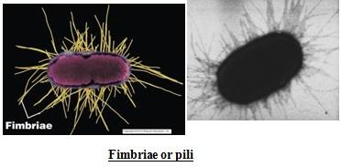

**FLAGELLA**

These are long tail like structures that help some pathogenic bacteria to move to a site where they can services

**TOXINS**

Some bacteria produce toxin (poisonous) compound that harm hosts. In human these toxins cause effects such as vomiting diarrhea, fever and muscle cramps for instance, toxins released by salmonella bacteria can cause severe diarrhea.

**Invasion and colonization**

Some bacteria attack themselves and become resistant to modes of treatment for examples, the bacterium they causes tuberculosis has become resistant to many antibiotics by transforming itself.

**RESISTANCES**

Some types of bacteria release a substance known as bio film that protects them from harmfully substances such as drugs.

**NON-PATHOGENIC BACTERIA**

Those are bacteria that are harmless even when they are on a plant or animal body.

**CHARACTERISTICS OF NON- PATHOGENIC BACTERIA**

1. Some non – pathogenic bacteria feed on substance that are harmfully to the environment and in the process neutralize them, for example, they neutralize petroleum waste from petroleum industries, disease and pesticide there by making the environment safe.
2. Bacteria such as rhizobium that are formed in the root nodules of leguminous plants, clostridium and Azotobacter help to convert atmospheric nitrogen to nitrates, plant need nitrate for their growth.
3. Bacteria in the stomach of ruminant animals such as goats and cows secret enzyme that help in the digestion of cellulose which forms a large part of the body of ruminant.
4. Bacteria in the animal gut manufacture vitamins K and B
5. Lactic acid bacteria produce lactic acid as a result of fermentation of carbohydrates. This is important in the production of fermented food and alcoholic drinks.
6. Autotrophic bacteria carry out photosynthesis.

**ADVANTAGE OF KINGDOM MONERA**

1. Bacteria that neutralize harmfully substance help clean the environment.
2. Bacteria found in the gut help animals to digest food and break it down into a form that can be absorbed into the body.
3. Vitamins produced by bacteria are important for the health of animals include man.
4. Fermentation is used in the production of yoghurt, vinegar and alcohol.
5. Controlled fermentation is used in the curing tea and tobacco and retting of flax, help to treat and preserve these products

Retting of flax is important in the production of fibre.

1. Some bacteria are used to produce antibiotics which are used to treat bacterial infections.
2. During photosynthesis autotrophic bacteria release oxygen into the atmosphere, oxygen in vital for the respiration in all living things.

**DISADVANTAGE OF KINGDOM MONERA**

1. Bacteria cause infection and disease in animal some of these are fatal.
2. A bacteria disease in crop cause decrease production and losses to farmers.
3. Bacteria cause food to decay and spoil
4. Due to Denitrifying bacteria in the soil convert nitrates to nitrogen. This reduces the nutrients available of plants.

**CHARACTERISTIC OF KINGDOM PROTOCTISTA**

1. They are eukaryotic.
2. Most are unicellular organisms. Only a few are multicellular.
3. Most live in or near water or in moist places.
4. Some are autotrophic (produce their own food) while others are heterotrophic (obtain nutrients from other organisms)
5. Some are mobile while others are stationery.
6. Some reproduce sexually and other asexually.
7. Many of them have locomotory structures such as cilia and flagella.

**PHYLA OF THE KINGDOM PROTOCTISTA**

The following table shows some of the phyla of kingdom protoctista.

|  |  |
| --- | --- |
| **Phylum** | **Example** |
| Rhizopoda/Amoebozoa | Amoeba |
| Apicomplexa | Plasmodium |
| Euglenophyta | Euglena |
| Ciliophera | Paramecium |
| Zoomastigina | Tryponasoma |

**AMOEBA**

Amoeba is free living, unicellular organisms, are found at the bottom of ponds and lichen.

**CHARACTERISTICS OF AMOEBA**

1. Amoeba has two layers of cytoplasm the outer layer called ectoplasm and the inner layer is called endoplasm.

Endoplasm is more fluid and contains granulose and vacuoles.

1. Amoeba is aquatic. They can be found in fresh water.
2. They use **pseudopodia** (cell extensions) for locomotion and to engulf food particles.
3. Contractile vacuoles regulate the amount of water in the fresh water amoeba.
4. A temporally food vacuole is formed to hold and digest food particles.
5. Waste products such as urea and ammonia are excreted by simple diffusion.
6. Oxygen and carbon dioxide are exchanged by simple diffusion.
7. Amoeba reproduce by binary fission

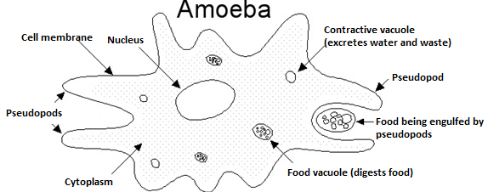

**Advantage of Amoeba**

Amoeba is commonly used in laboratories to study cell structure and function.

**Disadvantage of Amoeba**

Amoeba can cause diseases for example Entamoeba histolytica cause amoeba dysentery in human.

**PLASMODIUM**

Plasmodium is the parasite that can cause malaria in human being.

Plasmodium is transmitted by anopheles mosquito and sand flies ( vectors ) and the mammalian, birds and reptiles are hosts.

**CHARACTERISTICS OF PLASMODIUM**

1. They are unicellular.
2. They are parasitic, with very complex life cycles involving the host and the vector
3. They produce sexually in the vector and asexually when a plasmodium enters the human body. It attacks the red blood cells and the liver.

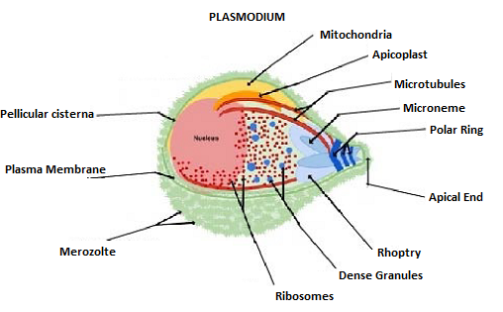

**Effect of plasmodium**

Plasmodium parasites cause malaria, can lead to inflammation of the spleen, miscarriage and anaemia due to the destruction of the red blood cells.  Severe malaria cause death.

**EUGLENA**

Euglena are characterized by the green scum that appears on stagnant water  
  
  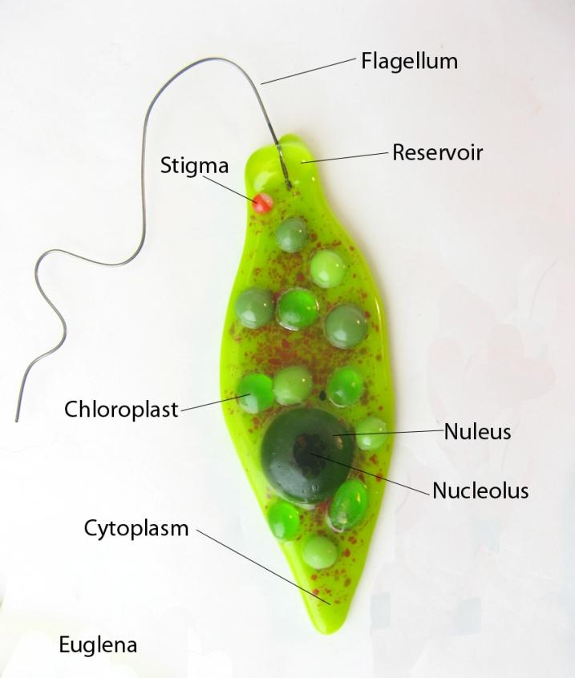

**CHARACTERISTICS OF EUGLENA**

1. They are unicellular.
2. They are found on both fresh water and salt water
3. Euglena move using flagella.
4. Some have chloroplasts for photosynthesis while others are heterotrophs.
5. They reproduce asexually
6. Some euglena have pellicle, the pellicle is flexible layer within the cell membrane. The pellicle helps euglena to change shape.

**ADVANTAGE OF EUGLENA**

* Euglena is used to treat sewage because of their unique capacity to change from being autotrophic when the euglena photosynthesis produce oxygen when they are heterotrophic they use oxygen. This help to keep oxygen levels balanced in sewage treatment plant.

Euglena called phytoplankton are important source of good for many types of aquatic micro – organism.

Phytoplankton they produce large quantities of oxygen during photosynthesis.

**DISADVANTAGE OF EUGLENA**

* Euglena blooms can be harmful to fish these are sudden increase in the number of microorganisms in the water.

**PARAMECIUM**

Characteristics of paramecium

1. They are unicellular and shipper – shaped.
2. Paramecia are heterotrophic.
3. They live in water
4. They use cilia to move
5. Their bodies are  covered with a pellicle
6. Food enters the organism through an open called the oval groove.
7. Paramecia feed on bacteria and microorganisms.
8. They reproduce either sexually or asexually
9. Contractile vacuoles regulated the amount of water in the cytoplasm.

              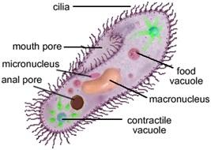

**Paramecium**

**Advantage of paramecia**

-Paramecia are eaten by small water animals

**Disadvantage of paramecia**

-Balantidium coli are a type of paramecia that cause disease.

It invades and destroys the living things intestine, causing diseases called balantidiasis